LINUX OS login bypassing

Step 1 : Start the system

Step 2 : Press up or down arrow when you get the option to choose your booting operating system.

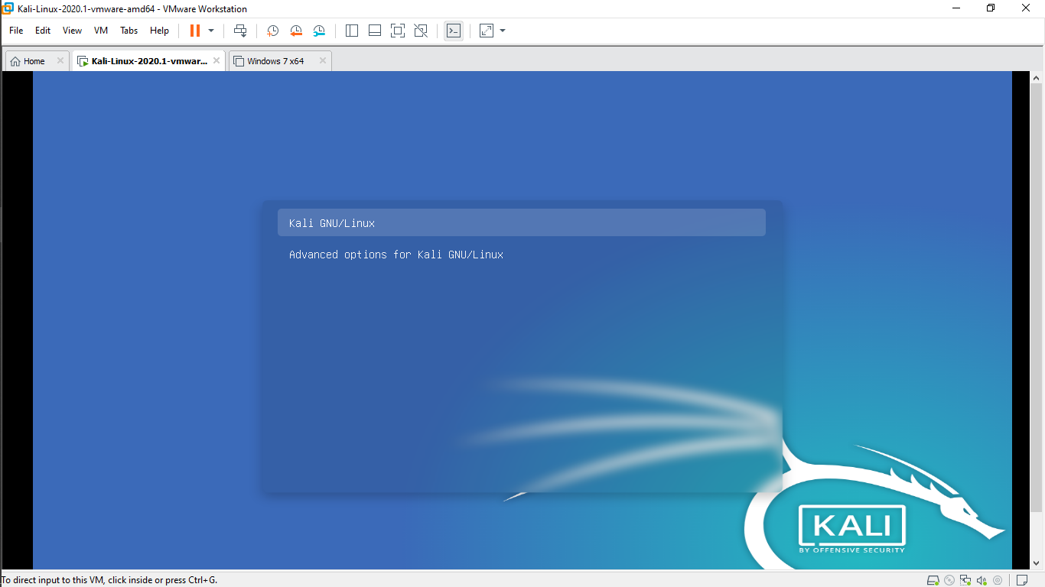

Step 3 : Once the timer of automatic booting option is off, select Kali GNU/Linux and press ‘E’ on keyboard

Step 4 : Find the line starting with ‘linux’.

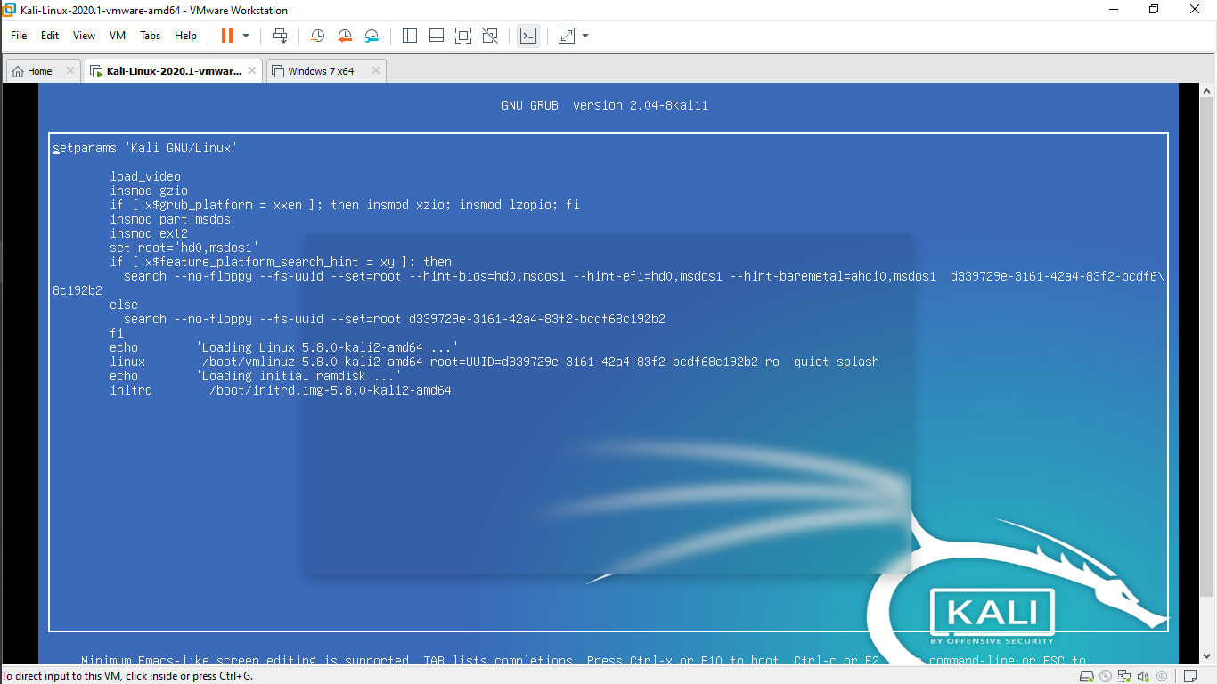

Step 5 : Edit the line starting with ‘linux’, change ‘ro’ into ‘rw’ and delete ‘quiet’ and add ‘init=/bin/bash’ by giving a space in the same line

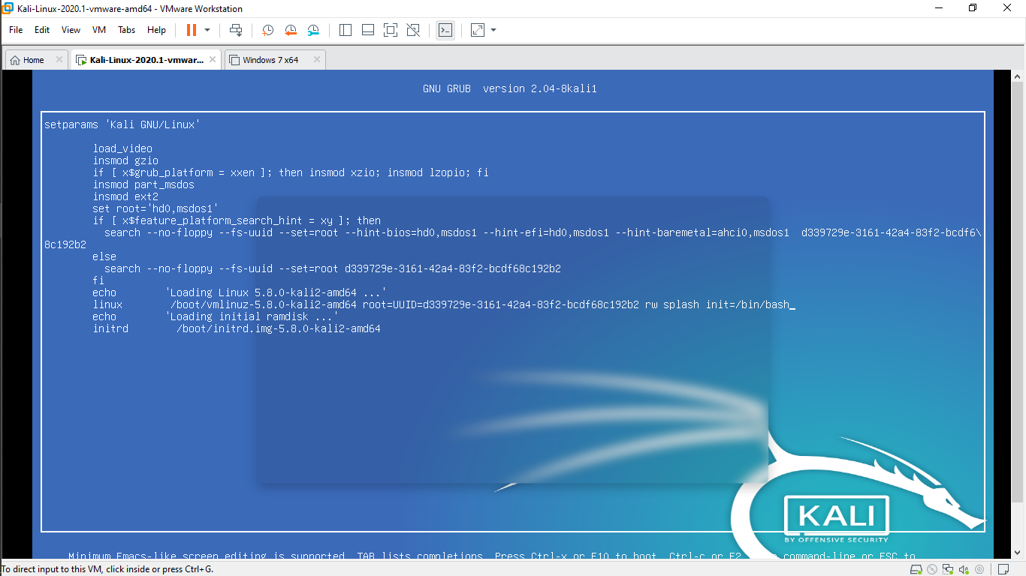

Step 6 : After making the give changes, press ‘ctrl+X’ or ‘fn+f10’ on key board.

Step 7 : Now a bin/bash shell which is default login shell of linux opens

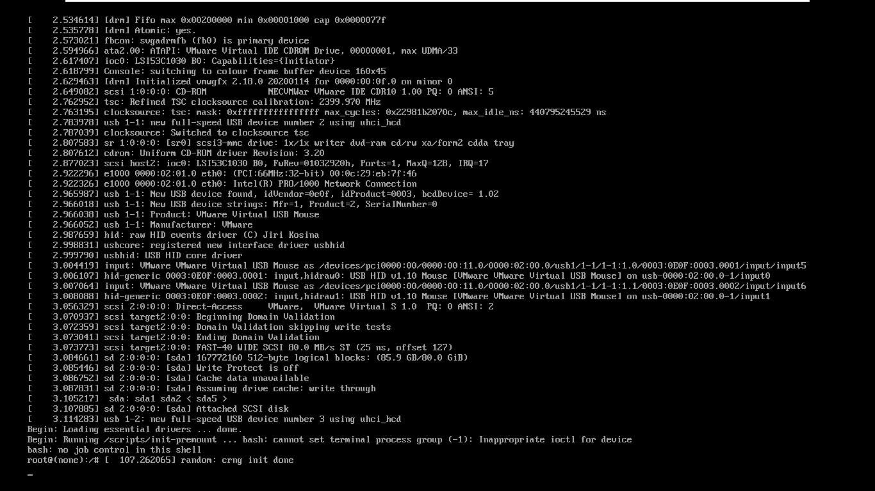

Step 8 : Press ‘ENTER’, and the shell is ready to take user defined input command.

Step 9 : Now enter ‘passwd’ and press ‘ENTER’.

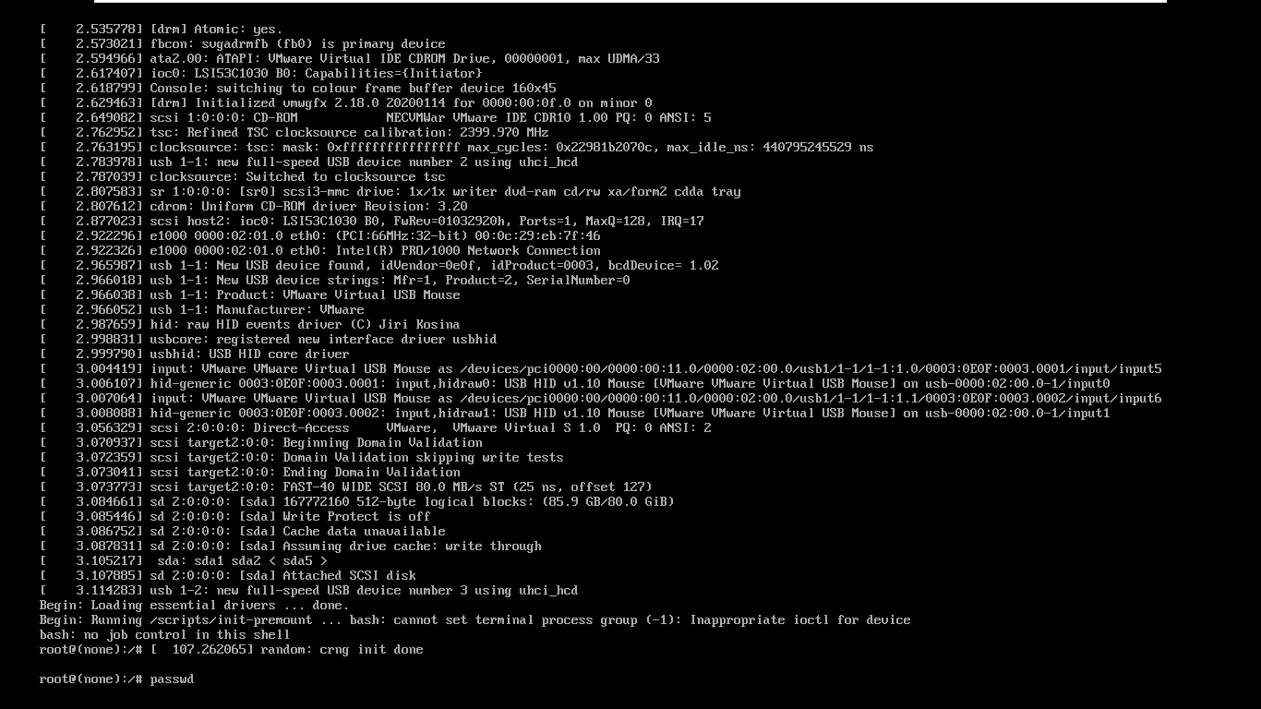

Step 10 : Now the shell asks for new password. Enter the new password.

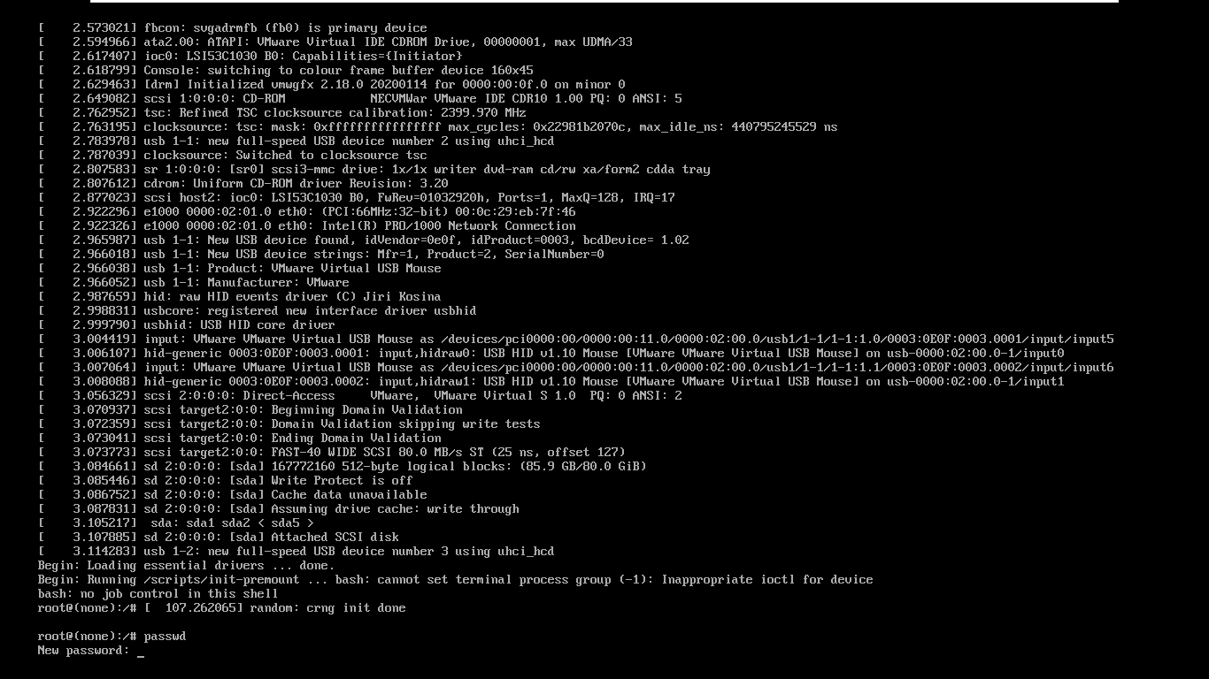

Step 11 : Now, retype the new password and press enter. And your password has been changed.

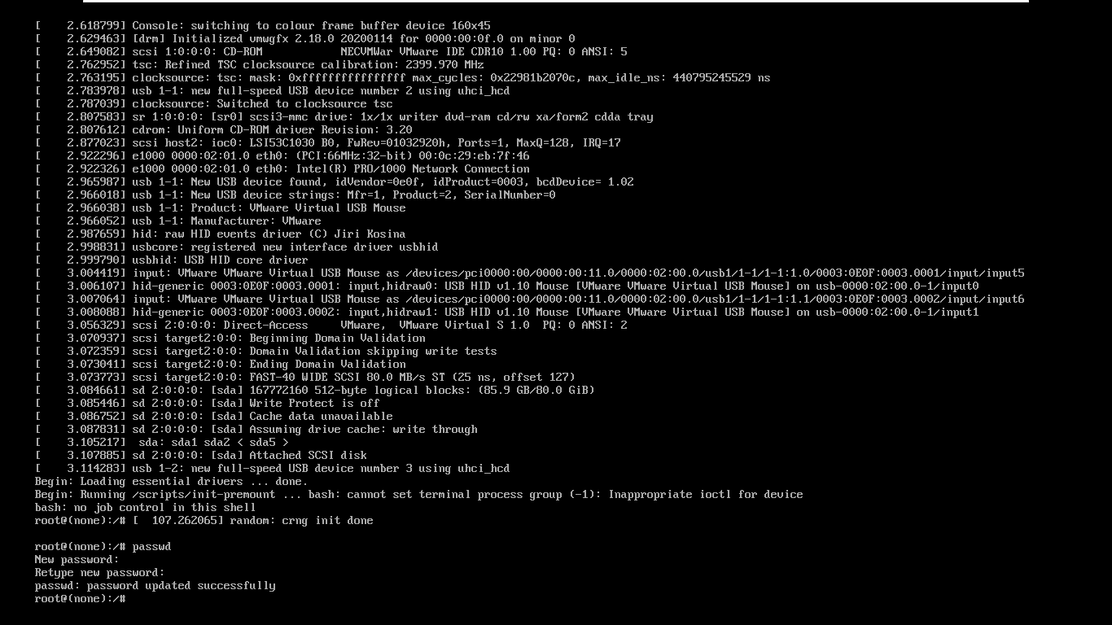

Step 12 : Now restart the system and login with new password.